|  |  |  |  |  |  |
| --- | --- | --- | --- | --- | --- |
| Date | 25-Nov-22 | | | Tester Name | Andrew McLaughlin |
| Environment | Penfax - Test | | | Login used |  |
| Operating System | Select OS | Version: | Update: | | |
| Software Used | Select Software | Version: | Update: | | |
| Select Software | Version: | Update: | | |
| Release version | 22.4.1 | | | | |
| Title | Death – Joint pensioner GP Expired | | | | |
| Test Type | Regression | | | | |
| Test Scenario | Death – Joint pensioner GP Expired | | | | |
|  |  | | | | |
| Expected Results | When a joint pensioner passes away and the GP is expired, there should be no benefit payable to anyone and their income benefit should end on the last day of the month they pass away. | | | | |
| Pass/Fail | Pass | | | JIRA# | N/A |

Describe your steps with screenshots:

Member is a widow and joint annuitant

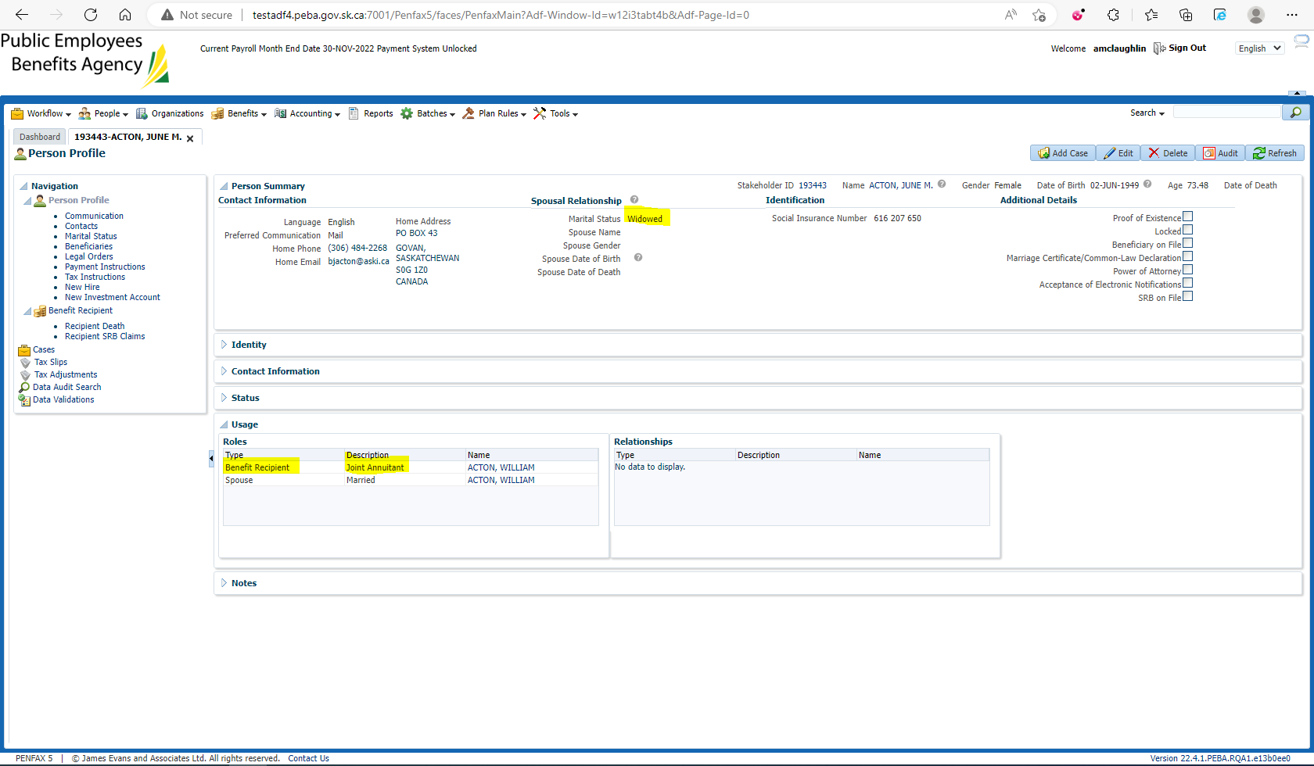

Member has their estate as their beneficiary 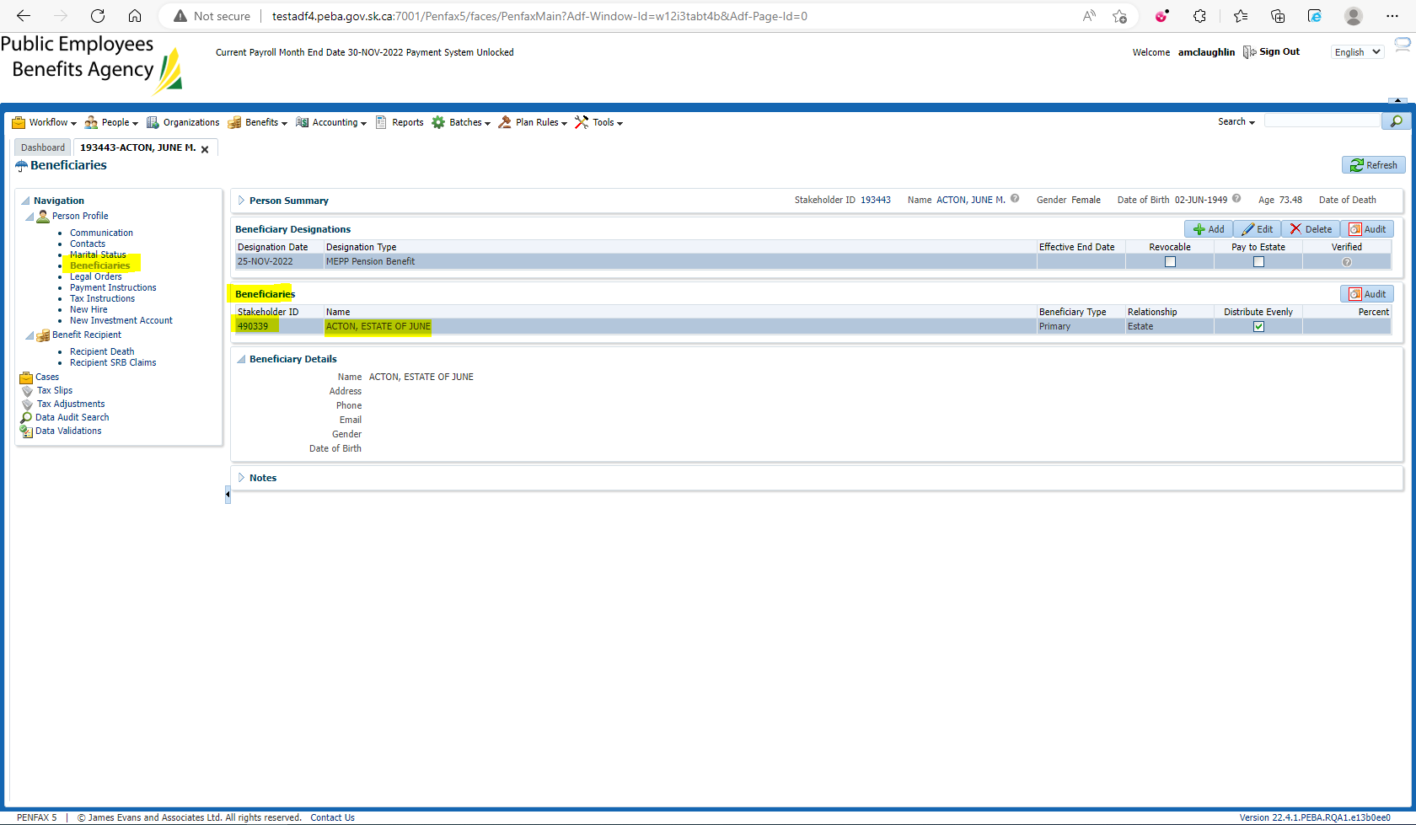

Enter Death Date 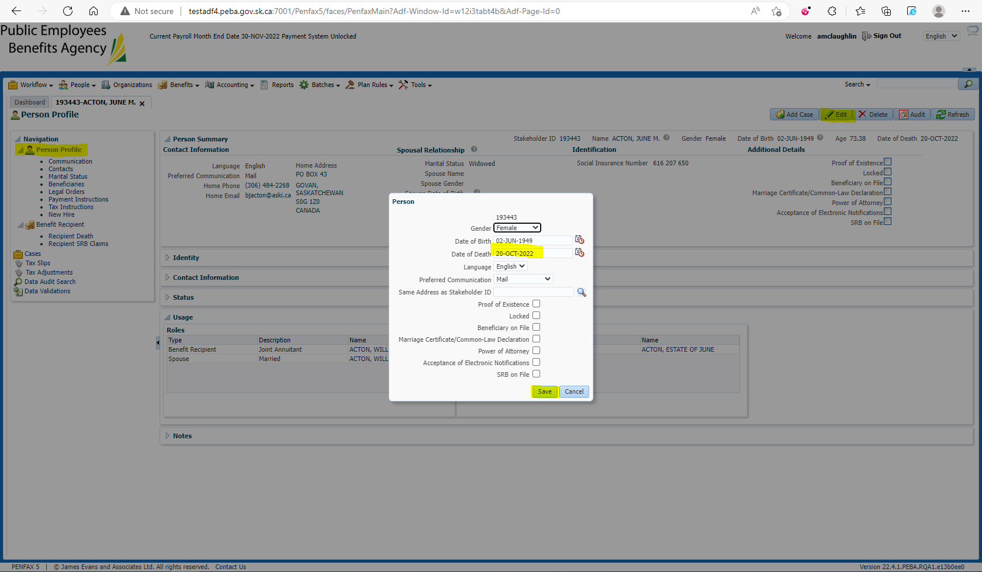

Verify the Retirement/Event Date and GP – 01-APR-2001 @ 5 Years 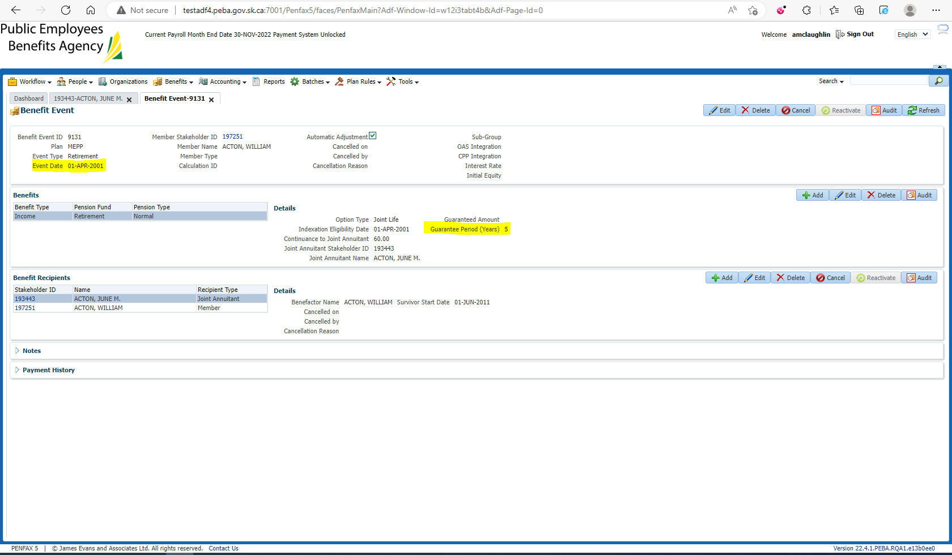

Open the Death Calc 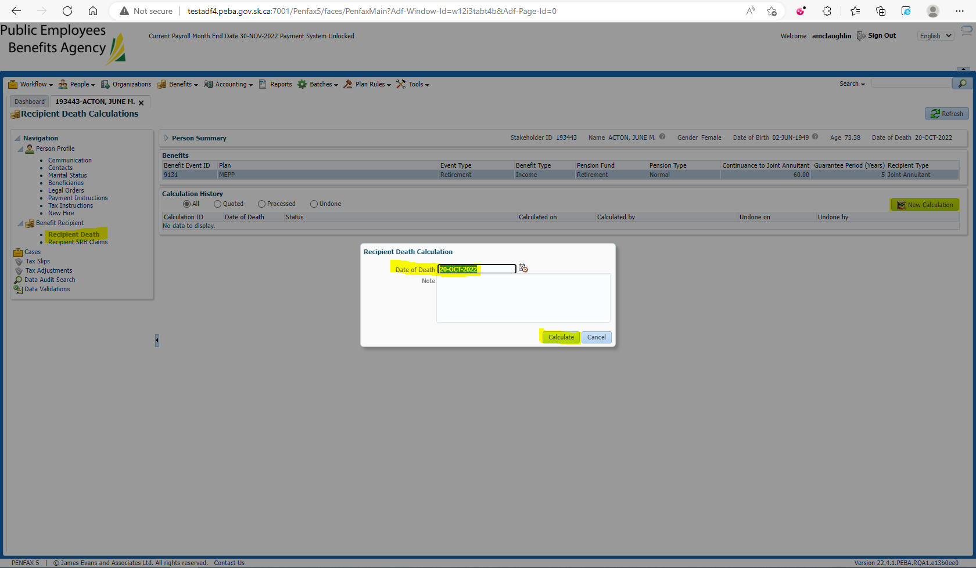

Verify that there is no Benefits Payable and Process x2 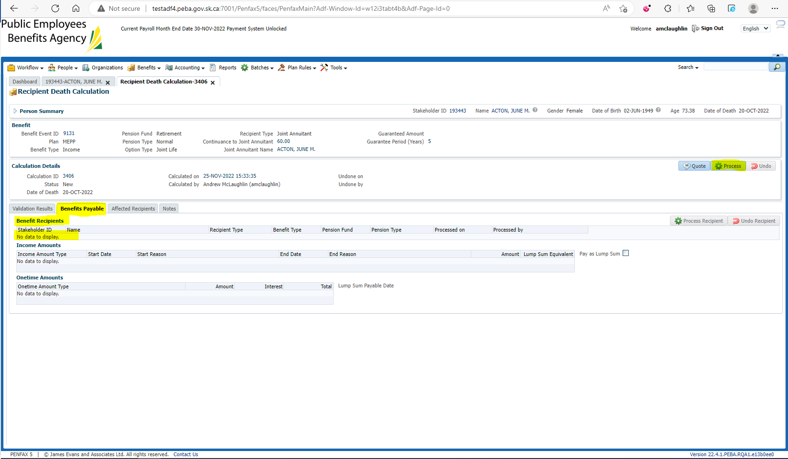

Verify under the member’s Benefit Recipient that the income benefit has been ended at the end of the month of death 